Team Edwards Lifetime Achiever Award Application form

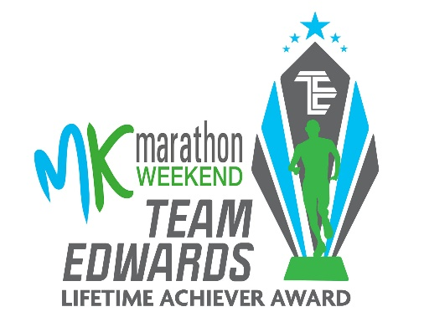
Have you achieved a seemingly impossible lifetime goal or overcome severe adversity to achieve something that perhaps seemed impossible? Anyone taking part in the MK Marathon or MK Half Marathon who thinks they have a compelling story of dedication with a running connection can apply for this amazing award. Steve Edwards and the MK Marathon team are looking for someone who has demonstrated a level of dedication & commitment to realise their potential and achieve a monumental goal that they perhaps didn't think was possible but were brave enough to follow their dreams and go for it.

APPLICATION FORM
Surname of
nominee

First name of nominee

Age on race day

Contact number.

Contact Email.

Which MK Marathon Weekend event are you participating in?
Have you taken part in the Milton Keynes Marathon Weekend before? (if so which event and when?)
Reason for Application (What’s your compelling story of dedication with a running connection to achieve a lifetime goal ? )

